Dynatrace Smartscape – Detailed Notes with Diagram

1. What Is Smartscape?
Smartscape is Dynatrace’s real-time environment topology map that visualizes applications, services, processes, hosts, and datacenters. It automatically builds an interactive visual graph without manual setup, showing both horizontal (e.g., service-to-service) and vertical (e.g., app to host) dependencies.

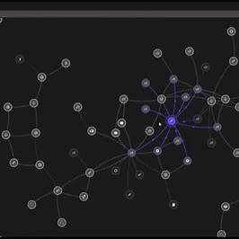

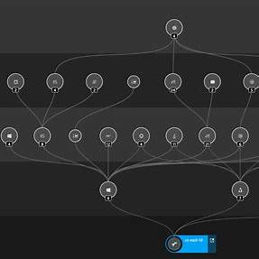

2. The 5 Layers of Smartscape
Smartscape topology includes:
1. Applications – User-facing web/mobile apps
2. Services – Business logic services
3. Processes – Processes executing services
4. Hosts – Servers or VMs
5. Datacenters – Cloud/physical infrastructure

3. Key Features & Visualization
• Automatic discovery via OneAgent
• Visualizes horizontal & vertical dependencies
• Detects process-level TCP/IP connections
• Active/inactive lines (dashed = timed out)
• Filters, overlays, and drill-down capability

4. Interactive Drilling & Troubleshooting
• Click nodes for entity overviews
• Explore cross-tier dependencies
• Highlighted problems in red
• PurePath, logs, metrics directly accessible

5. Smartscape on Grail & DQL Integration
Smartscape topology is stored in Grail, accessible via DQL for advanced use:
Examples:
smartscapeNodes "HOST"
smartscapeEdges "calls"

6. Hands-on Steps for Working with Smartscape
1. Open Smartscape via left menu
2. Choose layer (App, Service, etc.)
3. Zoom/pan to explore
4. Use filters (e.g., hide inactive)
5. Enable 'Show problems' for alerts
6. Click a node to drill down
7. Export or automate with API/DQL

7. Why Smartscape Matters
• End-to-end visibility
• Quick root-cause analysis
• Fully automatic
• Microservice and cloud-native ready
• Integrates with DQL and automation tools

Summary
Smartscape is the core visualization and mapping engine in Dynatrace. It delivers a dynamic, real-time map of your environment that supports deep insight, fast troubleshooting, and scalable observability.

